# Mapping in R

**Basic R packages:**

*Raster* (for mapping raster data and images)

*sp* or *spatial* (for mapping points, lines and polygons, etc.)

**Other packages:**

*Marmap* for marine mapping (see more details below)

## Spatial data sources:

**Bathymetry:**

**NOAA data sets:**

**Info on the ETOPO1 data set:**

[**https://data.nodc.noaa.gov/cgi-bin/iso?id=gov.noaa.ngdc.mgg.dem:316#**](https://data.nodc.noaa.gov/cgi-bin/iso?id=gov.noaa.ngdc.mgg.dem:316)

**Can also use the online grid extract tool:**

[**https://maps.ngdc.noaa.gov/viewers/grid-extract/index.html**](https://maps.ngdc.noaa.gov/viewers/grid-extract/index.html)

**Recommended citation**: Amante, C. and B.W. Eakins, 2009. ETOPO1 1 Arc-Minute Global Relief Model: Procedures, Data Sources and Analysis. NOAA Technical Memorandum NESDIS NGDC-24. National Geophysical Data Center, NOAA. doi:10.7289/V5C8276M [access date].

**GEBCO data sets:**

[**https://www.gebco.net/data_and_products/gridded_bathymetry_data/**](https://www.gebco.net/data_and_products/gridded_bathymetry_data/)

**Great barrier reef:**

The 3D depth model ‘Great Barrier Reef Bathymetry 2020 30m’ is now available on the AusSeabed Marine Data Portal:

<https://portal.ga.gov.au/restore/9e717082-1bd6-4567-91f5-424c55623cab>

**Marine maps of the Great barrier reef:**

[**https://open-aims.github.io/gisaimsr/index.html**](https://open-aims.github.io/gisaimsr/index.html)

**Environmental data:**

**Bio-oracle:**

[**https://www.bio-oracle.org/**](https://www.bio-oracle.org/)

## More on packages

**Marmap R package:**

Overview of the package and some easy to use codes:

[**https://www.molecularecologist.com/2015/07/marmap/**](https://www.molecularecologist.com/2015/07/marmap/)

**Marmap github page:**

[**https://rdrr.io/cran/marmap/**](https://rdrr.io/cran/marmap/)

**Marmap R Documentation website:**

[**https://www.rdocumentation.org/packages/marmap/versions/1.0.3**](https://www.rdocumentation.org/packages/marmap/versions/1.0.3)

**Instructions how to get open-source bathymetry data into R as raster layer**

<https://www.benjaminbell.co.uk/2019/08/bathymetric-maps-in-r-getting-and.html#anchor2>

The second part has nice instructions to customize the colors of your bathymetric maps:

<https://www.benjaminbell.co.uk/2019/08/bathymetric-maps-in-r-colour-palettes.html>

**Use NOAA grid extraction tool to download the area of your interest**

<https://maps.ngdc.noaa.gov/viewers/wcs-client/>

Use GEOtiff ETOPO1 bedrock and download file

To use in R analyses including marmap package I

Place the file in your working directory

Then import with into R with the raster package.

## Adding extras to maps:

North arrow and scale bars

<https://www.andybeger.com/2012/08/25/scale-and-north-arrow-for-maps-in-r/>

Scalebar is simple and easy in marmap!

**New marine mapping package:**

**ggOceanMaps:**

<https://mikkovihtakari.github.io/ggOceanMaps/index.html>

This one is interesting because it converts bathymetry rasters to vectors which makes rescaling the image size easier and probably looks smoother

## 3D Mapping

**Rayshader package:**

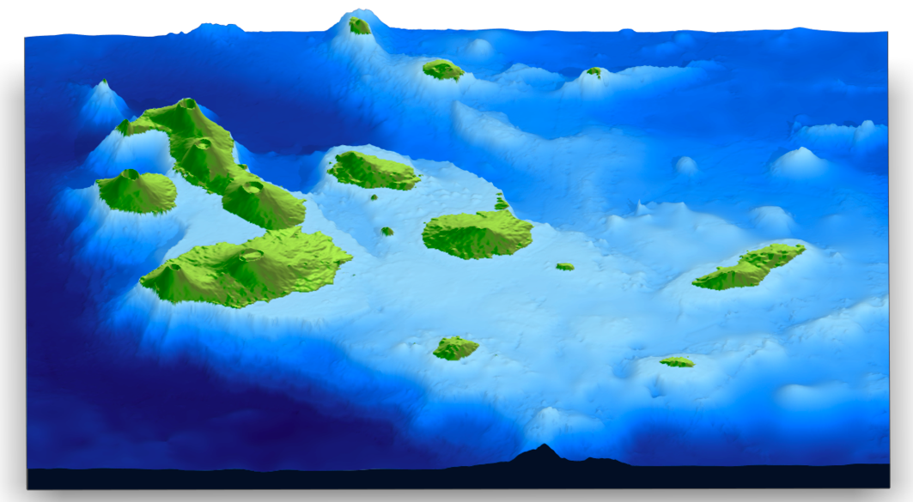

<https://wcmbishop.github.io/rayshader-demo/>

<https://www.rayshader.com/>

Best details on all functions are on the Github man-pages:

<https://rdrr.io/cran/rayshader/man/>

**3D maps can also be animated:**

[**https://www.tylermw.com/3d-maps-with-rayshader/**](https://www.tylermw.com/3d-maps-with-rayshader/)

**This one made a nice trail map using rayshader:**

[**https://www.simoncoulombe.com/2019/06/top-of-the-world/**](https://www.simoncoulombe.com/2019/06/top-of-the-world/)